OPERATING SYSTEM SECURITY AND FUNDAMENTALS (LINUX AND WINDOWS)
To install a Linux virtual machine using VirtualBox, download VirtualBox from its official site and a Linux ISO like Ubuntu, then create and configure a new VM with adequate RAM, storage, and the ISO as boot media before running the installer.
Alternatively, adjust Windows security settings via Windows Security app under Virus & threat protection to exclude VM-related folders or disable real-time protection temporarily during setup, but re-enable it afterward for safety.
VirtualBox Installation Steps
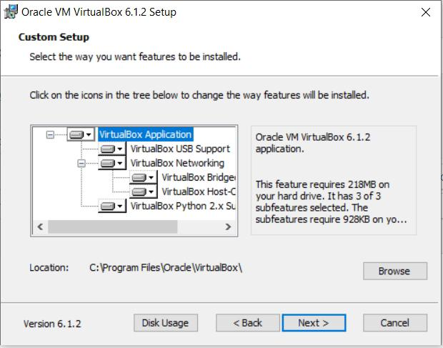
Download and install VirtualBox from virtualbox.org. Fetch a Linux distro ISO (e.g., Ubuntu from ubuntu.com), launch VirtualBox, create a new VM, allocate 4GB+ RAM and 20GB+ disk, attach the ISO, and start to follow the Linux install wizard.
Post-install, insert Guest Additions via Devices menu for better integration like shared folders and clipboard sync.

Windows Security Adjustments
Open Windows Security > Virus & threat protection > Manage settings, add VirtualBox and VM folders to exclusions to prevent interference during ISO mounting or VM boot.
Test VM startup after changes; this avoids false positives on virtual disk files without fully disabling protection.
User accounts, permissions and access control
User accounts, permissions, and access control mechanisms form the foundation of secure systems by regulating who can access resources and what actions they can perform. These elements ensure only authorized users interact with data or applications, minimizing risks like breaches or misuse. Common implementations include role-based and attribute-based models, often managed through identity and access management (IAM) tools.

Core Concepts
User accounts represent individual or group identities, authenticated via credentials like passwords, biometrics, or multi-factor authentication (MFA). Permissions define specific actions—such as read, write, or delete—granted to accounts on resources like files or databases. Access control mechanisms enforce these by evaluating rules during authorization, following principles like least privilege to limit exposure.

Key Models
- Role-Based Access Control (RBAC): Assigns permissions to predefined roles tied to job functions, simplifying management for teams; users inherit role rights without individual tweaks.
- Attribute-Based Access Control (ABAC): Dynamically grants access using user attributes (e.g., location, device) alongside roles for finer granularity.
- Discretionary Access Control (DAC): Resource owners set permissions directly, common in file systems but riskier due to potential over-sharing.
- Access Control Lists (ACLs): Resource-specific lists detailing allowed users/groups and their permissions levels.
File permissions in Linux
File permissions in Linux are managed using commands like chmod for access modes, chown for ownership changes, and ls -l for viewing details.
Viewing Permissions
The ls -l command displays long-format listings, showing permissions as a 10-character string (e.g., -rw-r—r--), owner, group, size, and timestamps. The first character indicates file type (- for regular file, d for directory), followed by read ®, write (w), and execute (x) flags for owner, group, and others.
Changing Permissions (chmod)
Use chmod to modify read, write, and execute permissions for owner (u), group (g), others (o), or all (a). Symbolic mode adds/removes with +, -, = (e.g., chmod u+x file adds execute for owner; chmod g-w file removes write for group). Numeric (octal) mode uses three digits (owner/group/others) where r=4, w=2, x=1 (e.g., chmod 755 file gives owner full access, group/others read+execute).
Changing Ownership (chown)
The chown command sets user and group ownership (e.g., chown user:group file changes both; chown user file changes only user). Root or file owner privileges are typically required; use -R for recursive changes on directories.
Common Examples
Ls -l file: View current permissions and owner.
Chmod 644 file: Owner read/write, others read-only.
Chown -R user:group dir: Recursively change directory ownership.

Administrator and standard user accounts
Administrator and standard user accounts differ primarily in the level of system access and control they provide, with administrators holding elevated privileges for managing the entire system. Standard users face restrictions to enhance security by limiting potential damage from errors or malware. These distinctions apply across operating systems like Windows, macOS, and others, though specifics vary slightly.

Key Differences
Administrators can install software, modify system settings, manage other users, and access all files on the device, while standard users are limited to changes within their own profile. Standard users cannot alter critical system files, add hardware drivers, or perform actions requiring elevated permissions without admin approval. For example, tasks like updating certain apps or configuring printers often prompt for admin credentials from a standard account.

Security Benefits
Using a standard account for daily tasks like browsing, gaming, or office work reduces risks, as malware typically cannot escalate privileges without explicit approval. Administrators bypass many restrictions but face higher vulnerability, so experts recommend standard accounts for routine use and elevating only when needed via tools like User Account Control (UAC) in Windows. This principle of least privilege minimizes the attack surface across personal and organizational setups.

Practical Examples
Windows: Standard users run apps but get UAC prompts for installs; admins approve changes affecting all users.

macOS: Standards modify personal settings but need admin rights for system-wide apps or user management.

Software/Services: In tools like BQE CORE, admins access all accounts and subscriptions, while standards see only their own.
Enable firewall (UFW in Linux or Windows Firewall).with diagrams
Enable UFW on Linux or Windows Firewall to secure your system by controlling inbound and outbound traffic. These firewalls block unauthorized access by default once activated.

Enable UFW on Linux
UFW (Uncomplicated Firewall) simplifies iptables management on Ubuntu and Debian-based systems. First, ensure it’s installed with sudo apt update && sudo apt install ufw if needed.

Run these commands in sequence:

Sudo ufw allow ssh or sudo ufw allow 22/tcp to permit SSH access and avoid lockout.

Sudo ufw enable to activate the firewall (confirm with ‘y’).

Sudo ufw status verbose to verify it’s active and view rules.

For example, allow HTTP/HTTPS: sudo ufw allow 80/tcp and sudo ufw allow 443/tcp.

Enable Windows Firewall
Windows Firewall is built-in and typically enabled by default, but confirm and configure it via the Security app. Access it through Start > Settings > Privacy & security > Windows Security > Firewall & network protection.

Toggle it on for Domain, Private, or Public networks as needed. For advanced rules:

Click “Advanced settings” > Inbound Rules > New Rule.

Select Port > TCP > specific ports (e.g., 3389 for RDP) > Allow > apply to profiles > name the rule.

Identify running processes and services.
Running processes and services vary by operating system and cannot be listed specifically without access to your machine. Common tools exist for monitoring them across platforms.

Windows
Use Task Manager (Ctrl+Shift+Esc) for a quick GUI view of processes and services, or run tasklist in Command Prompt for processes and sc query for services. Process Explorer from Sysinternals provides advanced details like handles and DLLs.

Linux/Unix
The ps aux command lists all processes with user, CPU, and memory usage; top or htop shows real-time interactive views. Services are managed via systemctl list-units –type=service on systemd systems.

macOS
Activity Monitor app displays processes; use ps aux or top in Terminal for CLI equivalents. Services often appear under LaunchDaemons/LaunchAgents in /Library or ~/Library.

Reduce attack surface, disable services
To reduce attack surface, disable services that aren’t required for your system’s role. Below is a practical, security-focused checklist with OS-specific steps you can apply immediately.

1. Inventory What’s Running (Before Disabling Anything)
You need to know what’s active and why.

Linux (systemd)
systemctl list-unit-files --type=service systemctl list-units --type=service --state=running

Windows
Get-Service | Where-Object {$_.Status -eq "Running"}
Document:
- Service name
- Purpose
- Required? (Yes/No)
- Dependency on other services

2. Commonly Unnecessary Services (Disable if Not Needed)

On Servers (Linux / Windows)
Service | Risk
FTP / TFTP | Cleartext credentials
Telnet | Cleartext remote access
SMBv1 | Legacy, widely exploited
NFS | Expands network attack surface
Avahi / mDNS | Network enumeration
Bluetooth | Remote attack vector
CUPS (printing) | Rarely needed on servers
RPC services | Lateral movement risk

3. Disable Services Safely

Linux (systemd)
Disable and stop:
systemctl disable --now <service>
Example:
systemctl disable --now avahi-daemon
Verify:
systemctl status <service>

Windows
Disable service:
Set-Service -Name "<service>" -StartupType Disabled Stop-Service -Name "<service>"
Example:
Set-Service -Name "Bluetooth Support Service" -StartupType Disabled

4. Minimize Network-Exposed Services
List listening ports:

Linux
ss -tulpen

Windows
netstat -ano
If a service listens on a port and is not required, disable it.

5. Harden Instead of Disable (When Required)
If a service must remain:
- Bind to localhost only
- Require authentication
- Use TLS
- Restrict via firewall
Example (Linux firewall):
ufw deny 631/tcp # CUPS ufw allow from 10.0.0.0/24 to any port 22

6. Prevent Re-Enablement
- Remove unused packages
- Disable auto-install/update features
- Monitor service changes
Linux:
apt purge <package>
Windows:
- Disable via Group Policy
- Use Security Baselines

7. Validate After Changes
- Reboot system
- Confirm services remain disabled
- Run vulnerability scan or port scan
nmap -sT -sV localhost

Best OS hardening practices
OS hardening involves configuring operating systems to minimize vulnerabilities and attack surfaces through secure settings, reduced privileges, and proactive maintenance. Best practices focus on eliminating unnecessary features, enforcing strict access controls, and ensuring timely updates across platforms like Windows, Linux, and macOS. These steps significantly reduce exploitation risks when implemented systematically.

Core Principles
Apply the principle of least privilege by limiting user and admin rights to essential functions only. Regularly audit accounts to disable or remove unused ones, and enforce strong password policies with complexity requirements and expiration. Segment networks using VLANs, firewalls, and ACLs to compartmentalize systems and block lateral movement during breaches.

Patching and Updates
Automate patch management for the OS, drivers, and software to address known vulnerabilities promptly. Enable secure boot and update BIOS/firmware to the latest versions, prioritizing vendor-specific guidance. Schedule vulnerability scans weekly and remediate findings immediately.

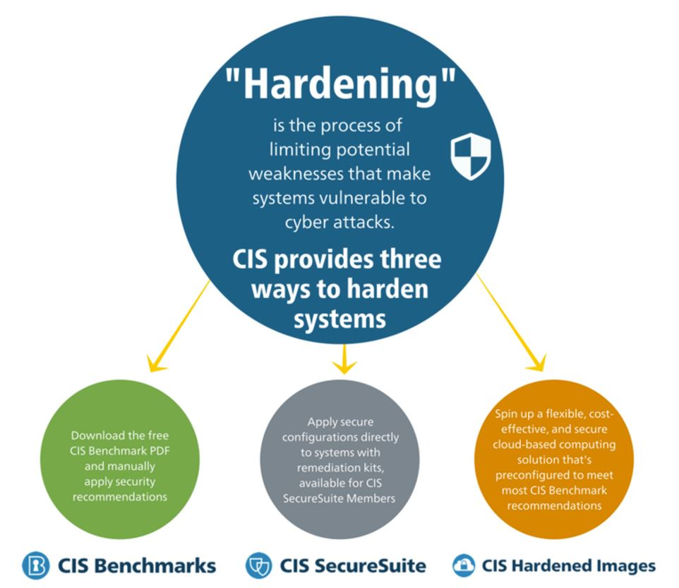
Access Controls
Configure firewalls to allow only necessary ports and services, disabling all others. Implement OS-level controls like account lockouts after failed logins, MFA where possible, and role-based access. Use file system permissions and registry restrictions to prevent unauthorized modifications.

Encryption and Logging
Encrypt data at rest with tools like BitLocker or FileVault, and in transit via TLS/secure protocols. Enable comprehensive logging for activities, errors, and warnings, retaining logs securely for incident response. Deploy antivirus, IDS/IPS, and software whitelisting to block malware and unapproved executables.

